Can Acai Bowls Fuel the Meteoric Rise of KSA’s Cafe and Coffee Chain Industry by 2027? – Ken Research
KSA's acai bowl market expected to surge to SAR ~150 Mn by 2027, fuelled by global culinary trends and a rising appetite for healthy, nutritious food and beverages.
STORY OUTLINE
- Acai bowl market in KSA expected to reach SAR ~150 Mn by 2027, driven by global culinary trends and health-conscious consumers.
- Riyadh leads as the primary hub for acai bowl vendors, while Jeddah emerges as a bustling hub for restaurants and cafes.
- Acai bowl players focus on offline strategies like loyalty programs and bundling, as well as online strategies like influencer marketing and campaigns.
- Acai bowl players experience peak season during summer with high seat occupancy, indicating the popularity of this refreshing treat.
- Menu diversity and innovation, along with a focus on quality, pricing, and customer experiences, are key for acai bowl players to differentiate themselves.
- Acai Bowls Take Over Riyadh and Jeddah
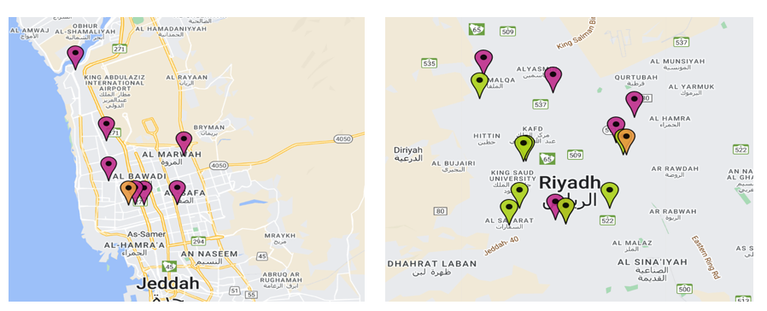
Concentration of Acai Bowl Outlets in Riyadh and Jeddah

- Riyadh takes the lead as the primary hub for acai bowl vendors in Saudi Arabia, with a majority of prominent players such as Oak berry, Yogi, and Moon Shell strategically locating their outlets within the city.
- Oak berry and Moon shell have established a strong presence in Jeddah, strategically situating a majority of their outlets in close proximity to gyms, shopping malls, and complexes. With Jeddah's growing working population, the city has emerged as a bustling hub for restaurants and cafes.
- In 2022, the combined sales of Oak berry, Moon shell, and Yogi surpassed the impressive milestone of 500,000 acai bowls. These three popular acai bowl vendors experienced remarkable success, demonstrating the growing demand and popularity of this healthy and delicious treat among customers.

- Get Ahead of the Game: Offline and Online Marketing Strategies That Shine!
Major Acai Bowl Players KSA
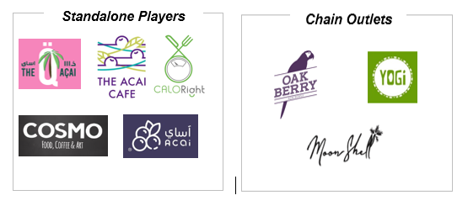
To learn more about this report Download a Free Sample Report
- Offline Promotion Strategies
Reward Points and Loyalty Programs: Earn points on purchases, redeem for discounts and gifts, enhancing customer satisfaction and loyalty.
Bundling Complementary Products: Offer discounted packages, like 4 small Acai cups with different flavours, to provide value and variety.
Clear Focus on Unique Features: Promote acai bowls as a lifestyle choice, offer unique merchandise, like phone covers and keychains.
- Online Promotion Strategies
Influencer Marketing: Partner with fitness coaches, lifestyle bloggers, and food bloggers on social media for collaborative promotions.
Emerging Social Media Platforms: Utilize Snapchat, Pinterest for influencer marketing, recipe sharing, and captivating visuals.
Campaigns and Advertisements: Execute online campaigns, contests, and targeted ads on platforms like Instagram to reach the desired audience.
- Game Changers: How Acai Bowl Players are Shaking Up the Industry!
Global Acai Berry Market Share, By Application (2022)
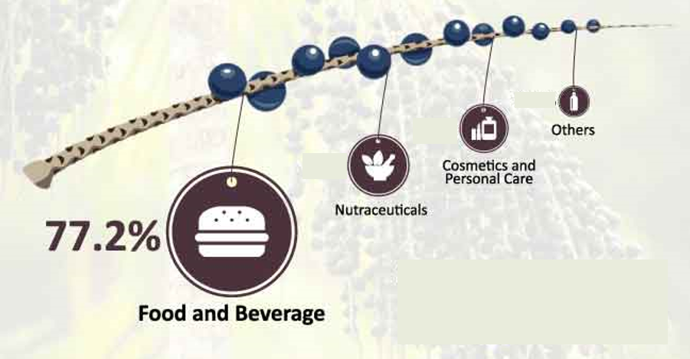

Visit this Link: – Request for custom report

- The Kingdom's Acai, Smoothie, and Juice players experience their peak season during summer, with a majority of them boasting over 30% seat occupancy.
- In 2022, the top-selling menu items generated over 20% of the total revenue, indicating their popularity among customers. Furthermore, a significant number of acai bowl players complement their offerings with a diverse range of smoothies and juices.
- Acai bowl players are proactively striving to distinguish themselves by focusing on aspects such as food quality, diverse menus, competitive pricing, online ordering options, robust delivery infrastructure, exceptional customer experiences, and the adoption of innovative models like cloud kitchens.

Conclusion: With the projected surge in the KSA's acai bowl market and the rising appetite for healthy food and beverages, acai bowls have the potential to fuel the meteoric rise of the café and coffee chain industry. Acai bowl players, through strategic marketing, innovation, and catering to evolving consumer preferences, are poised to make a significant impact in the industry by 2027.
According to ken Research, the Acai bowls market will be predominantly led by standalone establishments. However, they anticipate a significant growth rate for chained establishments, projecting a CAGR of around 10-15% from 2022 to 2027. By 2027, it is expected that there will be over 60 chained acai bowl establishments, generating more than half of the market's revenue.

